
EDINBURGH INSTRUMENTS
2 Bain Square, Kirkton Campus, Livingston,
Scotland. EH54 7DQ. UK
+44 (0)1506 425 300

FS5 VALIDATION PROCEDURE

THIS DOCUMENT IS COMMERCIALLY CONFIDENTIAL
SEE COPYRIGHT NOTICE

Document control

ISSUE | DATE | ECN | Signatory | Review | Issue Approval
DRAFT 12 | 17/08/19 |  | IR, PL | DC, AG, FV

Review schedule

The twelfth draft of this document was reviewed and improved by:

Distribution list

INTERNAL ONLY (Review only)
Edinburgh Instruments – soft copy (production documents)
Edinburgh Instruments – hard copy (FS5 production area)

© Copyright EDINBURGH INSTRUMENTS, 2014
All rights reserved. No portion of this document may be reproduced or transmitted in any form or by any means without the express prior written permission of EDINBURGH INSTRUMENTS.

The product or procedure described in this manual is subject to continuous development and while every effort has been taken to ensure that the information given is correct, Edinburgh Instruments Limited cannot accept any liability for errors and omissions or their consequences.

Contents
2 Standard Test Procedure 4
All done with the SC-05 cassette 4
2.1 Silicon Detectors 4
2.2 Light Leaks 4
2.3 Monochromators calibration 5
2.4 Signal-to-noise ratio 6
2.5 Correction Files Scans 7
2.6 Silicone Detector Correction File 8
2.7 Reference Samples scans 9
3 Additional options / cassettes 11
3.1 Options 11
1. TCSPC 11
2. Multi-Channel Scaling (MCS) 16
3. Polarisers 17
4. NIRA+ Detector (InGaAs) 19
5. NIR PMT-1400 Detector 22
6. NIR PMT-1700 Detector 22
3.2 Cassettes 23
1. SC-06 Dual Sample Holder for Absorption 23
2. SC-10 Solid Sample Holder (Upright/Tilted) 23
3. SC-15 Solid Sample Holder (Horizontal) 23
4. SC-20 cooled cuvette holder with magnetic stirrer 24
5. SC-22 Temperature Controlled Solid Sample Stage 24
6. SC-25 TE-Cooled Sample Holder - Standard Range 25
7. SC-26 TE-Cooled Sample Holder - Extended Range 26
8. SC-27 TE-Cooled Sample Holder - 4-Position 26
9. SC-28 Heated Sample Holder – Powders 27
10. SC-30 Integrating Sphere 29
11. SC-40 Plate Reader 30
12. SC-41 Microwell Plate Reader 31
13. SC-50 Optical Fibre Launcher 31
14. SC-70 Liquid Nitrogen EPR Dewar 31
15. SC-80 Liquid Nitrogen Cryostat 31
3.3 Accessories 31
1. SCA-1 Solid Sample Holder 31
2. SCA-2 Solid Sample Holder with Rotation 31
3. SCA-3 Syringe Port 31
4. SCA-6 Stopped-Flow 31
5. SCA-7 Solid Sample Holder with Rotation 31
6. SCA-8 Electroluminescence Sample Holder 31
4 Light Path Naming 32
5 Validation 34
5.1 Correction Files 34
Correction File Generator 34
Creating Correction Files Manually 38
5.2 χ² Factor Validation 38
5.3 Test Records 39

Standard Test Procedure

All done with the SC-05 cassette
Create a folder inside Job# folder. Name it ‘Val’ and save everything done during validation in this folder.
Install Fluoracle from the USB provided. Plug in the FS5 and start the software.
Open Signal Rate window and enable Engineering mode (CTRL + ALT + E). Password is “eiops”.
Click on TCC or CB (depending on which card the system has) and check the detector thresholds. For Standard PMTs threshold should be between -50 and -30 mV.
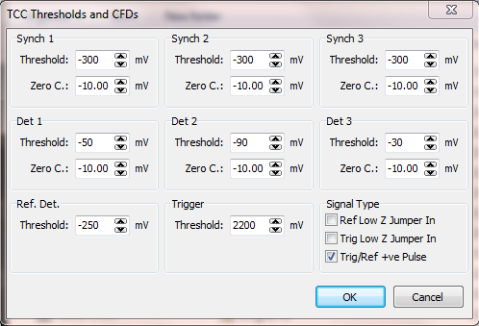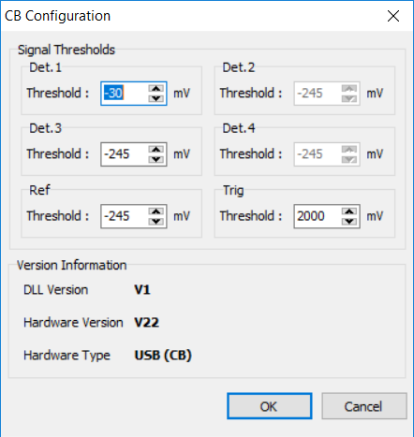
Figure 1:Threshold voltage calibration a) TCC board b) CB board

Detector thresholds depend on throughput and dark counts.
Standard practice should be to set it to -40mV at first and adjust it accordingly if throughput is low or dark counts are high. This should be decided after Sensitivity test (1.3) is finished.

Silicon Detectors
Switch Xe Lamp off. Check dark counts on reference and transmission detectors are between 1500-2000cps. If they are not, go to Engineering Mode → Silicon Detectors and adjust their Offset values.
Switch Xe lamp on and check the ref and trans det counts at 468nm and 5.5nm bandpass – set gain on transmission detector for counts just below saturation.

Typical Settings Gain Offset
Reference 1 (fixed) ~1810
Transmission 52 (approx.) ~1783
(Gain should generally not be altered)

Light Leaks
No sample Set Signal Rate: Ex λ = 200 nm, Ex slits = 0 nm;
Em λ = 435.8 nm , Em slits = 5 nm.
Use a torch light to carefully check the emission monochromator for light leaks. Cover any such areas with a small piece of flock.

Monochromators calibration

Excitation monochromator

Sample: None Set Signal Rate: Ex λ = 350 nm, Ex slits (Δλ_{ex}) = 0.3 nm;
Em λ = 200 nm, Em slits (Δλ_{em}) = 0 nm.

Excitation Grating Calibration
Run an Excitation Calibration scan (Alt + 1) Ranges: 470 – 480 nm; 820 – 830 nm.

Theoretical peaks at: 473.4nm and 823.2nm; Peaks need to be within ±0.5 nm to be in spec.
Target - Ex cal should be easy to get within 0.1 nm
To move peak to the right, decrease zord. If peaks are too far apart, increase alpha.

Zord adjust: Set-up → User calibrations → Ex mono
Alpha adjust: Ctrl + Alt + E → excitation grating set-up screen.
|| Save as ‘ex cal’
Note: Repeat for each grating present and save accordingly (e.g. ex cal 250nm, Ex cal 300nm, etc.)

Excitation Grating Repeatability

Run Excitation Repeatability scan (Alt + 4) 20 repeats || Save as ‘ex rep’

Pass/Fail: The peaks should all be within 0.3nm of each other. No clear drift pattern should be seen.

Excitation Reference

Run an Excitation Reference scan (Ctrl+4) step: 1 nm; dwell time: 0.3 sec; Number of scans: 1.

Range: 200 – 1000 nm subtract background: off
For an Ozone generating bulb start at 180nm instead of 200nm. || Save as ‘ex ref’
Filter transitions drops @ 410nm should be ~14% and @ 680nm should be ~1%

Note: Repeat for each grating present and save accordingly (e.g. ex cal 250nm, Ex cal 300nm, etc.)

Transmission Reference
Run a Transmission Reference scan (Ctrl + T) step: 1 nm; dwell time: 0.3 sec; Number of scans: 1.
Range: 200 – 1000 nm Ex. Cor: off sub bck: off
For an Ozone generating bulb start at 180nm instead of 200nm. || Save as ‘trans ref’

Note: Repeat for each grating present and add grating blaze when saving (e.g. “trans ref 450nm”)

Emission monochromator

Sample: Hg (Mercury) source, Set Signal Rate: Ex λ = 200 nm, Ex slits = 0 nm;
Em λ = 365 nm, Em slits = 0.3 nm.

Disable emission filter wheel: Options → Measurement options → untick em filter

Emission Grating Calibration
Run an Emission Calibration Scan (Alt + 2)
Theoretical Lines: 365.0, 404.7, 435.8, 546.1, 580.0, 730.0, 809.3, 871.7. Specification is +/-0.5nm.
Note: Repeat for each grating present and save accordingly || save as ‘em cal’

Emission Grating Repeatability
Run Emission Repeatability scan (ALT + 5) 20 repeats || save as ‘em rep’
Once finished re-enable the emission filter wheel before continuing.

Signal-to-noise ratio

Make sure the filter wheel is enabled: Options → Measurement Options → Filter wheel control

Sample: water sample 1 Set Signal Rate:

Ex λ = 350 nm, Ex slits = 5 nm;
Em λ = 397 nm, Em slits = 5 nm.

Align the Xe lamp to get the best signal on the emission detector using the two lamp adjustment screws.
The Water Raman signal should be higher than 400,000cps usually (is above 500,000cps) (except for PMT1010)
Take a snip of the signal rate window || save as ‘wr sr’

Run a sensitivity scan (ALT + 3)
SNR(SQRT) must be above 6000 (usually is above 8000)(except for PMT1010). If it is too low, check for light leaks (there would be an extra small peak around 435.8nm) or make sure that the Em filter wheel is re-activated.
(include port A or B if more than one PMT detectors are present) || save as ‘snr’
Before closing the scan export it in ASCII format for future reference and analysis.
Press: File → Export ASCII or (Ctrl + F) and make sure that the ‘include properties’ box is ticked.

Correction Files Scans

Create sub folders for each emission light path with corresponding names inside of ‘val’ (e.g. PMT900 SC05, PMT1010 SC30, InGaAs SC05, etc.). Save all the scans in the right folder.
Correction files are needed for each emission light path over the usable range: If the system has an SC-05, SC-30 and/or an SC-50 cassette or any additional gratings or detectors it will need a separate correction file for each one.
Ranges:
- Visible PMT-900: | 200-900nm |  | - NIR PMT-1400: | 900-1500nm
- Visible PMT-980: | 200-1000nm |  | - NIR PMT-1700: | 900-1800nm
- Visible PMT-1010: | 200-1100nm |  | - NIR InGaAs 1.65um: | 600-1800nm
Make sure the filter wheels are enabled: Options → Measurement Options → Filter wheel control
Switch Xe Lamp off and plug the SC-60 (1 or 2) in the system. Note: The system will not recognise SC-60-1 as it is an older cassette version, disable sample module detection (CTRL + Alt + E) and choose SC-60 from the sample module menu to use it.
Press the button to switch on the lamps inside the cassette (red = Tungsten, blue = Deuterium).

Deuterium (blue) Set Signal Rate:

Ex λ = 200 nm, Ex slits = 0 nm;
Em λ = 400 nm (peak), Em slits = 0 nm.

Wait for a minute for the lamp to come on, then increase Em bandwidth slowly to get a good signal below saturation (~1’000’000cps) and run a kinetic scan (τ) for 1800 seconds to ensure the lamp has warmed up and has stabilised.
Adjust emission bandwidth to get approximately 1’000’000cps. (Δλ=~0.6nm)
Run an Emission Correction scan (CTRL + 5) subtract background: off
Range: 200 – 400nm; Step: 1nm; Dwell time: 2 sec; repeats: 1
Change lamp source name to ‘SC60-1(or 2) D’ (fig.2) || save as ‘D Raw’
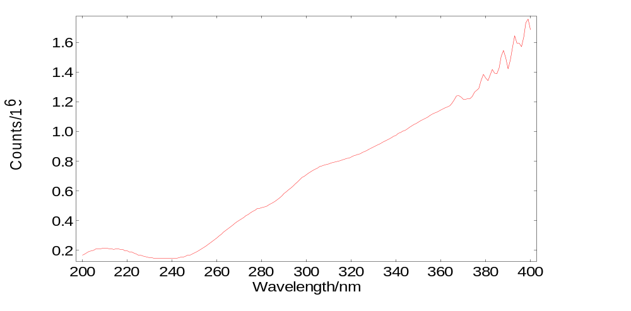
Figure 2: Raw Deuterium lamp scan (PMT900)
Tungsten (red) Set Signal Rate: Ex λ = 200 nm, Ex slits = 0 nm;
Em λ = 600 nm (peak), Em slits = 0 nm.
Wait for a minute for the lamp to come on, then increase Em bandwidth slowly to get a good signal below saturation (~1’000’000cps) and run a kinetic scan (τ) for 1800 seconds to ensure the lamp has warmed up and has stabilised.
Adjust emission bandwidth to get approximately 1,000,000cps. (Δλ=~0.2nm)
Run an Emission Correction scan (CTRL + 5), subtract background: off
PMT-900 range: 300 – 900nm; PMT-980 range: 300 – 1000nm; PMT-1010 range: 300 – 1100nm;
InGaAs (NIRA+) see section 2.1.4; NIR PMT-1400 see section 2.1.5; NIR PMT-1700 see section 2.1.6.
Step: 1nm Dwell time: 2 sec; repeats: 1
Change lamp source name to ‘SC60-1(or 2) T’ (fig.3) || Save as ‘T Raw’ or ‘T Raw (detector)’
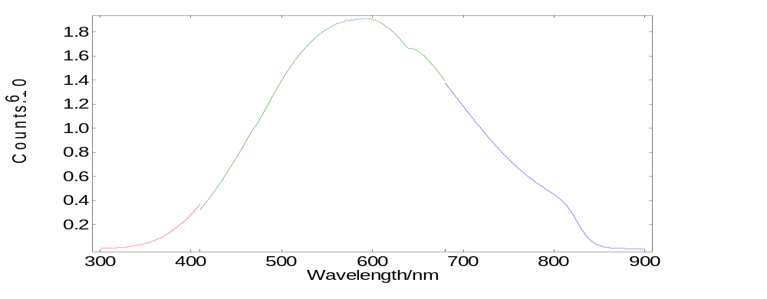
Figure 3: Raw Tungsten lamp scan (PMT900)
After you’ve finished enable sample module detection: Options → Sample modules → Ctrl + Alt + E

Silicone Detector Correction File
In order for the instrument to give an accurate representation of the emission spectra it needs to level the Xenon Lamp emission spectra. This is done by applying an excitation correction factor everything we measure
First copy the required correction files from the server (\\server1\Analytical Software Records\Spectral correction files\Si Ref correction) onto your computer (C:\ProgramData\Edinburgh Instruments\Fluoracle\Correction).
‘Si diode data_FS5.FS’ file for the Standard Xe Bulb
‘Si diode data_FS5 from 180nm.FS’ for the Ozone Xe Bulb
Then in Fluoracle got to: Options → Correction Files… → Other (Ctrl + Right click next to emission tab)
Click on ‘Browse’ next to the ‘Reference Detector File’ bar and choose the following file:
Standard Xe Bulb: C:\ProgramData\Edinburgh Instruments\Fluoracle\Correction\Si diode data_FS5.FS
Ozone Xe Bulb: C:\ProgramData\Edinburgh Instruments\Fluoracle\Correction\Si diode data_FS5 from 180nm.FS and
click Ok.

Reference Samples scans
Measure a number of samples and their respective solvents to validate the correction files.
For every sample aim for ~ 900 000 cps at peak. Adjust Ex bandwidth to achieve. Then run an Emission scan (Ctrl + M) for each of the following samples. Make sure the filter wheels are enabled
Save the sample scans measured for each light path inside the corresponding light path folder.
Note: Excitation Correction: On; Subtract Background: On – for all scans
Visible Range 200 – 900nm | 2AMP (EI-1) | Set SR: | Ex λ = 285 nm, |  | Ex slits = ~1.5 nm; (Aim to get 900’000cps)
Visible Range 200 – 900nm |  |  | Em λ = 370 nm (peak), |  | Em slits = 0.7 nm.
Visible Range 200 – 900nm |  |  | Range: 300 – 500 nm, |  | step: 1 nm, dwell: 0.5 sec |  | || save as ‘EI-1’
Visible Range 200 – 900nm | QBS (EI-2) | Set SR: | Ex λ = 350 nm, |  | Ex slits = ~1 nm; (Aim to get 900’000cps)
Visible Range 200 – 900nm |  |  | Em λ = 435 nm (peak), |  | Em slits = 1 nm.
Visible Range 200 – 900nm |  |  | Range: 370 – 600 nm, |  | step: 1 nm, dwell: 0.5 sec |  | || save as ‘EI-2’
Visible Range 200 – 900nm | C153 (EI-3) | Set SR: | Ex λ = 420 nm, |  | Ex slits = ~1 nm; (Aim to get 900’000cps)
Visible Range 200 – 900nm | (Optional) |  | Em λ = 530 nm (peak), |  | Em slits = 1 nm.
Visible Range 200 – 900nm |  |  | Range: 450 – 700 nm, |  | step: 1 nm, dwell: 0.5 sec |  | || save as ‘EI-3’
Visible Range 200 – 900nm | DCM (EI-4) | Set SR: | Ex λ = 450 nm, |  | Ex slits = ~1.5 nm; |  | (Aim to get 900’000cps)
Visible Range 200 – 900nm |  |  | Em λ = 623 nm (peak), |  | Em slits = 1 nm.
Visible Range 200 – 900nm |  | VIS | Range: 460 – 850 nm, |  | step: 1 nm, dwell: 0.5 sec |  | || save as ‘EI-4’
Visible Range 200 – 900nm | LDS (EI-5) | Set SR: | Ex λ = 520 nm, |  | Ex slits = ~7.5 nm; (Aim to get 900’000cps but below ref sat)
Visible Range 200 – 900nm |  |  | Em λ = 730 nm (peak), |  | Em slits = 3 nm.
Visible Range 200 – 900nm |  |  | Range: 570 – 900 nm, |  | step: 1 nm, dwell: 0.5 sec |  | || save as ‘EI-5’
NIR up to 950nm | DCM (EI-4) | Set SR: | Ex λ = 450 nm, |  | Ex slits = ~5 nm; (Aim to get 900’000cps)
NIR up to 950nm |  |  | Em λ = 635 nm (peak), |  | Em slits = 5 nm.
NIR up to 950nm |  |  | Range: 550 – 800 nm, step: 2 nm, dwell: 1 sec || save as ‘EI-4 (detector)’
NIR up to 950nm | LDS (EI-5) | Set SR: | Ex λ = 520 nm, |  | Ex slits = ~5 nm; (Aim to get 900’000cps)
NIR up to 950nm |  |  | Em λ = 730 nm (peak), |  | Em slits = 5 nm.
NIR up to 950nm |  |  | Range: 620 – 950 nm, step: 2 nm, dwell: 1 sec || save as ‘EI-5 (detector)’
NIR+ up to 1750nm | LDS (EI-5) | Set SR: | Ex λ = 520 nm | Ex slits ≤ 8 nm (or below ref detector saturation);
NIR+ up to 1750nm | (see 2.1.4) |  | Em λ = 730 nm (peak), | Em slits = 10+ nm. (+1000cps > dark counts).
NIR+ up to 1750nm |  | Range: 600 – 950 nm, step: 5 nm, dwell: 10 sec, repeat: 4 || save as ‘EI-5 InGaAs’
NIR+ up to 1750nm |  |  | SECTION UNDER DEVELOPMENT
Table 1: Reference Samples

Refer back to section 1.5 to see what validation scans are needed for each detector range

Anthracene Absorbance Reference Excitation, Emission and Absorption (~0.12ABS)

Sample: Anthracene Ref correction: on Subtract background: on for both scans
Abs scan (Ctrl + T) Ex λ = 270 - 395 nm, Ex slits = 2 nm; Step = 1nm,
Em λ = 200 nm, Em slits = 0 nm. Dwell = 0.5 sec.
Sample: Cyclohexane
Abs Ref scan (Ctrl + T) Ex λ = 270 - 395 nm, Ex slits = 2 nm; Step = 1nm,
Em λ = 200 nm, Em slits = 0 nm. Dwell = 0.5 sec.

Put the two Absorption (Abs) scans in the same window then press: Analysis → Absorbance (T) and choose the Cyclohexane (Anthracene solvent) scan as the reference scan then press ok.
Excitation and Emission should be put on the same graph in test records and Absorption should be presented as a separate graph.
||Save as: ‘Ant Absorbance (T)’

Alternatively use batch measurement and the automated SC-05 cassette (SC05 PL) to measure the samples reference samples:
SC05PL Make sure the filter wheels are enabled

Note: Emission light path needs to be named ‘Visible PMT900’ to be able to use batch the measurement designed for these scans.
- Disable cassette module detection and choose SC-05
- Place samples in order (back to front): 2AMP (EI-1) in position 1, then LDS (EI-5) in position 2, QBS (EI-2) in 3, DCM (EI-4), Anth (A), Cyclo (C) last.
- Engage filter wheels on ex and em.
- Check white arrow is on white dot inside SC05PL
- Load batch "New SC05PL Batch PMT900 MMcC edit2" from \\server1\Shared\PLinton\Multi Sample Holder Calibration scans\Test New System.
- Turn autosave OFF
- Press "RUN" and flick switch on SC05PL UP at the same time. (Check green LED goes on inside Arduino PCB) and close lid.
- After measurement, wait 1 minute for the float return, switch it OFF (down).
- Save Every Scan with a relevant name. (e.g. “2AMP”, “LDS”, etc.)

Additional options / cassettes

Options

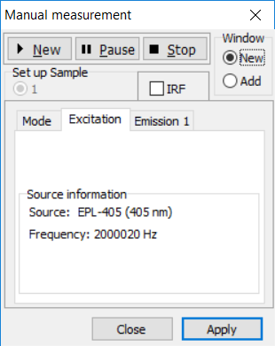
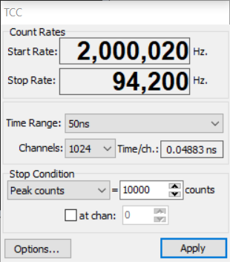
TCSPC
Put beam damper in front of the transmission detector.
Set the laser. Choose TCSPC from light paths.
Check:
- laser alignment.
- the interlock is working.
- the dial pulse period matches the frequency displayed on signal rate in Fluoracle (500ns pulse width = 2’000’000Hz)
- Synch 1 Threshold is -200mV (Signal Rate → Engineering Mode → TCC)
Turn the ND filter attenuator until no light passes through.
Put Ludox sample in (Scattering block for EPLED with λ<300nm)
Set SR: Em λ = Laser λ_{L}, Em slits = 0.3 nm (up to 10nm for EPLEDs)
Open the Lifetime measurement window (Ctrl + L) (fig.4) and turn the Neutral Density (ND) filter up to get a stop rate below saturation point of 5% of the start rate. Close the window.
Run an Emission Scan (Ctrl+M): Ex Cor: off; Sub Bckd: off
Range: (λ_{peak}-10nm)→( λ_{peak}+10nm), step = 0.1 nm, dwell: 0.1-1 sec.
Open: Setup → EPL laser Setup and delete all the lasers except for the ones shipping with the system. Name them appropriately (e.g EPL-405) and put the actual measured wavelength in the right column (e.g 403.7nm).
Figure 4: Lifetime Measurement Window
Open: Setup → MCS laser Setup and do the same as above for the lasers in this list.
Run a Lifetime Measurement (Ctrl + L) of Ludox also called IRF (Instrument Response Function).
Set delay and fine adjust from options so that the IRF peak appears around the first ~10% of each time window (Fig.5). Increasing fine adjust will move the peak to the left and delay moves it to the right.
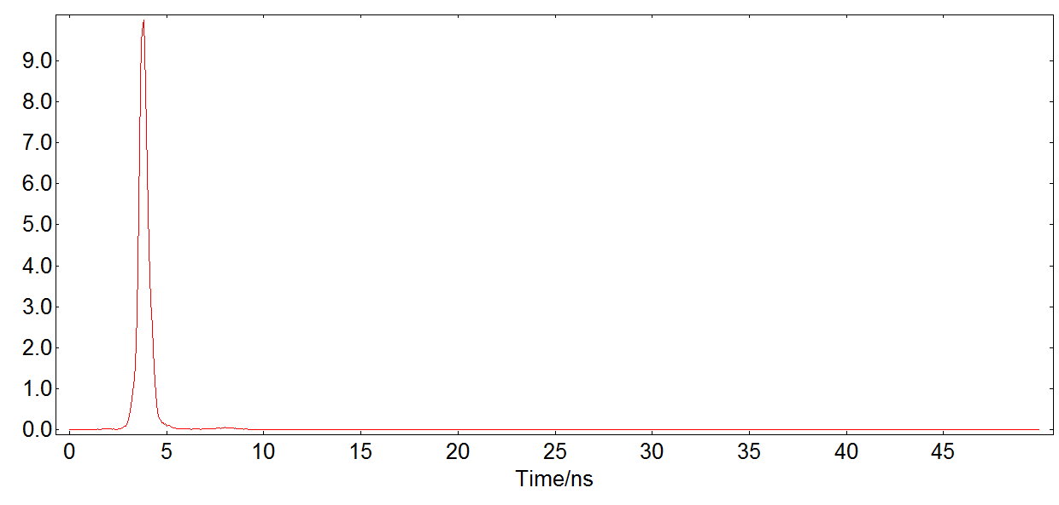
Figure 5: Lifetime peak in linear scale at 50ns time range
Choose the right sample to match the laser’s λ to the excitation absorbance range and the expected lifetime of a given sample. The lifetime of the sample needs to be shorter than the pulse frequency.
Sample | Excitation Peaks λ_{ex} (nm) | Absorbance range Δλ_{ex} (nm) | Emission Reference Peak λ_{EmRef} (nm) | Expected lifetime τ1
2AMP (EI-1) | 229, 300(max) | 210 – 240, 260 – 340 | 364 | 9.5ns
C153 (EI-3) | 420 | 370 - 460 | 530 | 4.1ns
Anthracene (A) | 340, 356, 375(max) | 310 – 385 | 399 | 5.2ns
Rhodamine B | 554 | 490 - 580 | 579 | 1.8ns
LD700 | 594, 645 | 540 – 670 | 672 | 1.4ns
Europium | 393.5 | 405 | 592 | 116.3µs
Fluorescein | 490 | 440 - 510 | 512 | 4.1ns
Table 2: TCSPC/MCS sample selection criteria

Open the ND attenuator filter to maximum transmission.
Put the Chosen sample in Set SR: Em λ = λ_{EmRef}, Em slits = to get signal below the saturation point (<5% of the pulse repetition rate/frequency. Aim for ~3%).
Open the dialogue for Manual lifetime measurement (Ctrl + L) and select the following parameters:
Time range: 20 -100 ns, 1024 channels, Stop condition:10 000 peak counts → Press ‘►New’
Put Ludox in. Set SR: Em λ = Laser λ_{L}, Em slits = Keep the same as for the sample
Turn the ND filter up to have roughly the same signal as for the sample (~3% of pulse rate).
Open the lifetime measurement window, tick ‘IRF’ and ‘add’, → start another scan ‘►New’
Open: Analysis → Exp. Reconvolution fit (Ctrl + R) (fig. 6), then put in a guess for the lifetime ~10% of the fitting range (e.g. τ₁ = 5ns.). Pass/Fail criteria: χ² must be between 1 - 1.3, if it is not increase the fitting range start point to only fit the decay tail without the rising edge if it’s >1.3 or decrease the end point if it’s <1.
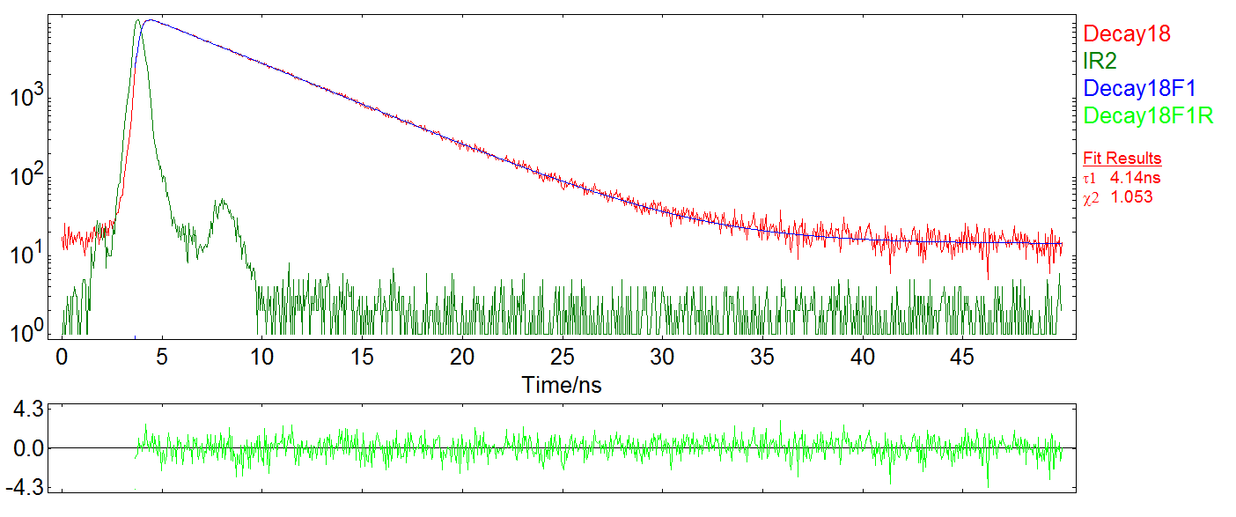
Figure 6: Exponential Reconvolution fit.
||Save as: EPL### Sample name fit. e.g. ‘EPL405 C153 fit’

Note: The decay should have a straight slope in log scale as it begins to descend (i.e. no waves or second peaks should be present).

Detector Threshold and Voltage VS Instrument Response Function (IRF)
The threshold is a setting that allows us to discriminate all the unwanted pulses produced by the PMT.
All the pulses produced that have an amplitude below that threshold will be ignored by the software.
The graph below represents the relationship between the unwanted random pulses produced by the PMT and the useful signal triggered by the incoming photons

ADD GRAPH

The actual signal response of the PMT will be a curve which is affected by these two and will look like this:

ADD GRAPH

As you can see there is a point where the number of useful information starts to dominate over the noise. At this point the we can start to distinguish the light pulses from the noise background. This is the point where we should set the TCC threshold (V_{th1}).
However it should be noted that increasing the PMT voltage as in the case of an NIR+ TE cooled (H10330C) detector, that has a variable bias voltage supply, makes it more sensitive to the incoming light but also produces more unwanted pulses/noise. The graph below represents what would happen if the PMT Voltage is increased.

ADD GRAPH

Here we see that the Voltage difference stretches the graph and our previous Voltage setting isn’t enough to discriminate all of the noise anymore. Therefore the system needs a higher threshold (V_{th2}) setting.
Note: The threshold should not be set too high because ASK TONY or JOHN. Therefore it should never be set higher than -70mV???

Nonetheless if the threshold is set too low than the TCSPC lifetime will show pre-pulses that will affect the rising edge of the reconvolution fit (see graphs below).
This is why there is a lower and a higher limit threshold setting for each detector/card/voltage combination.
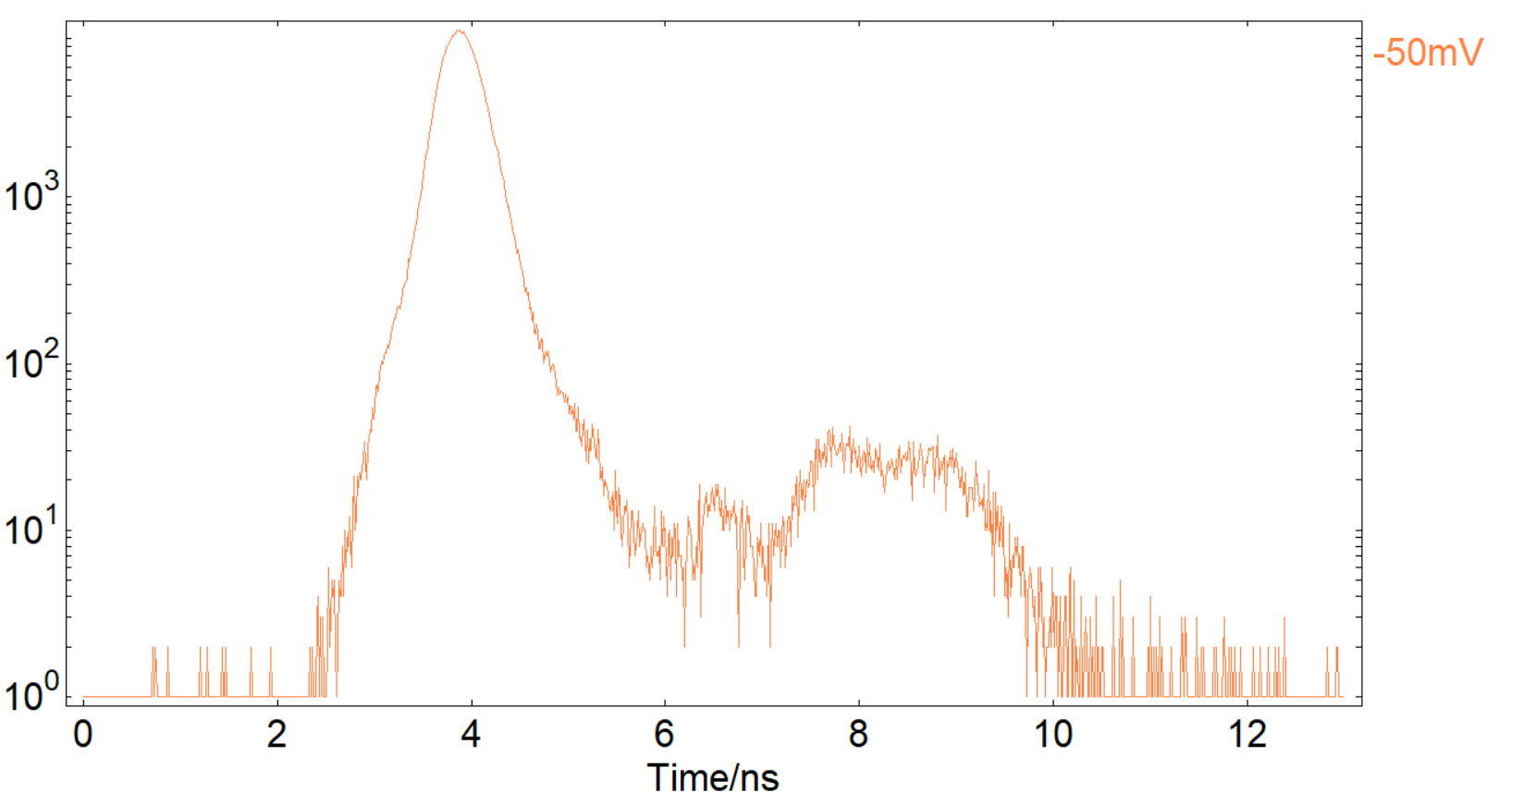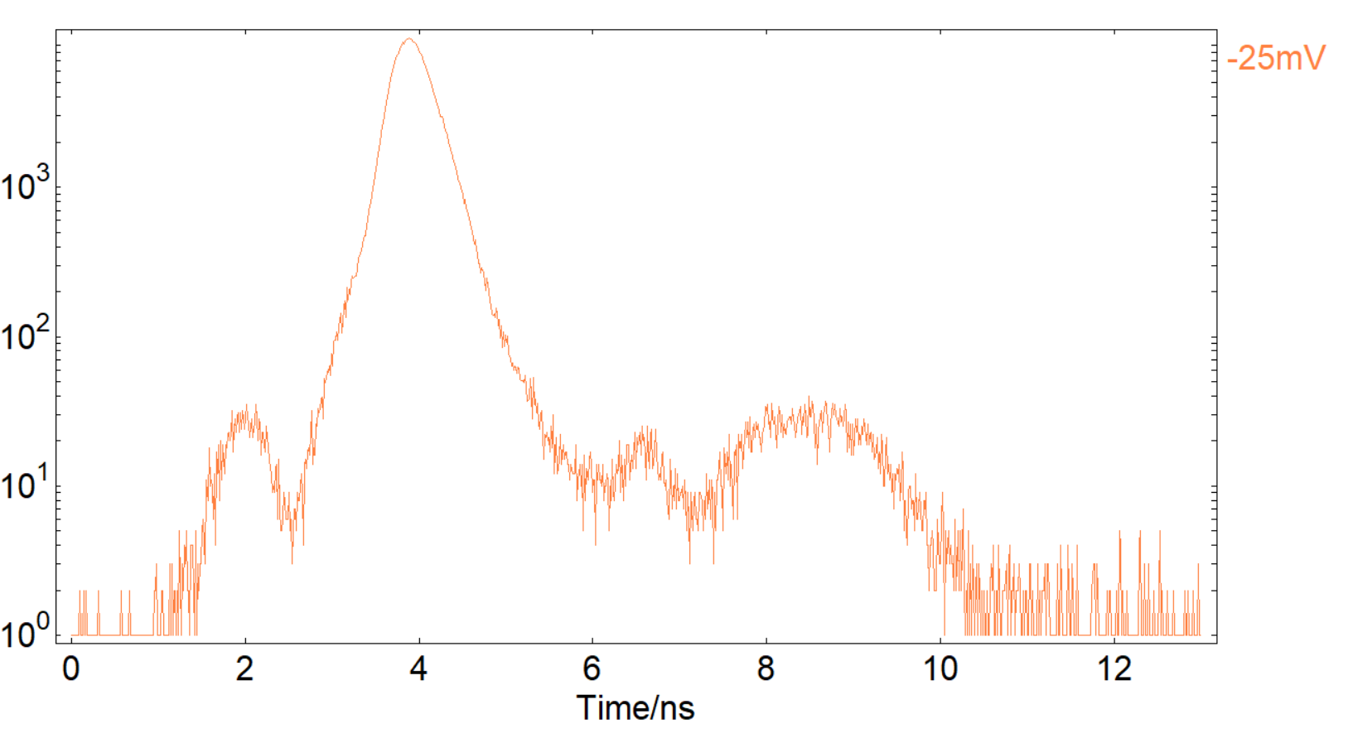
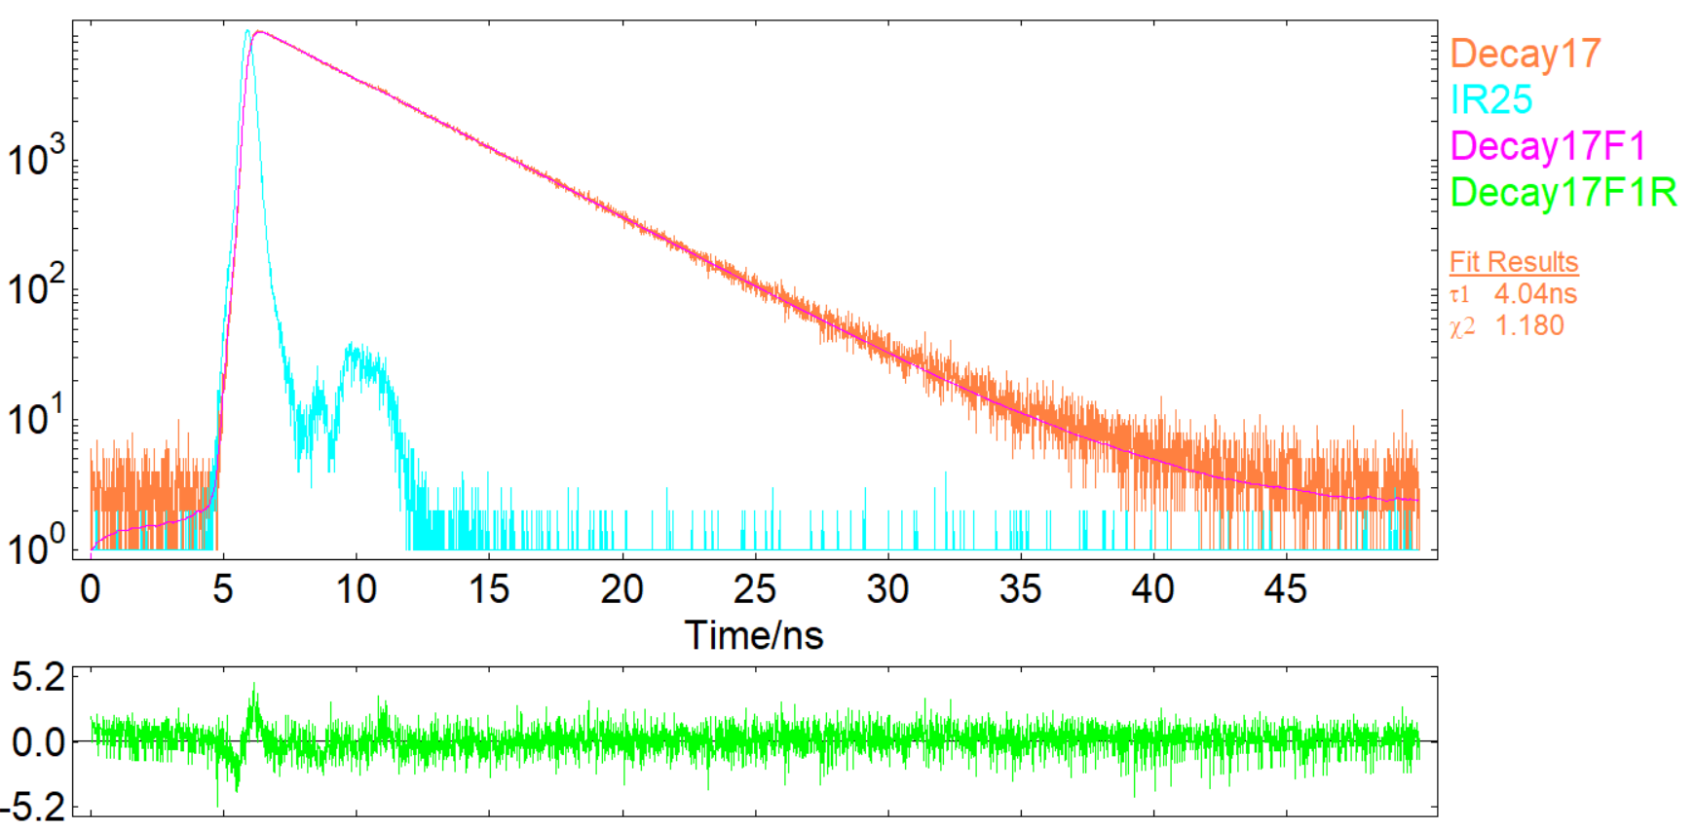
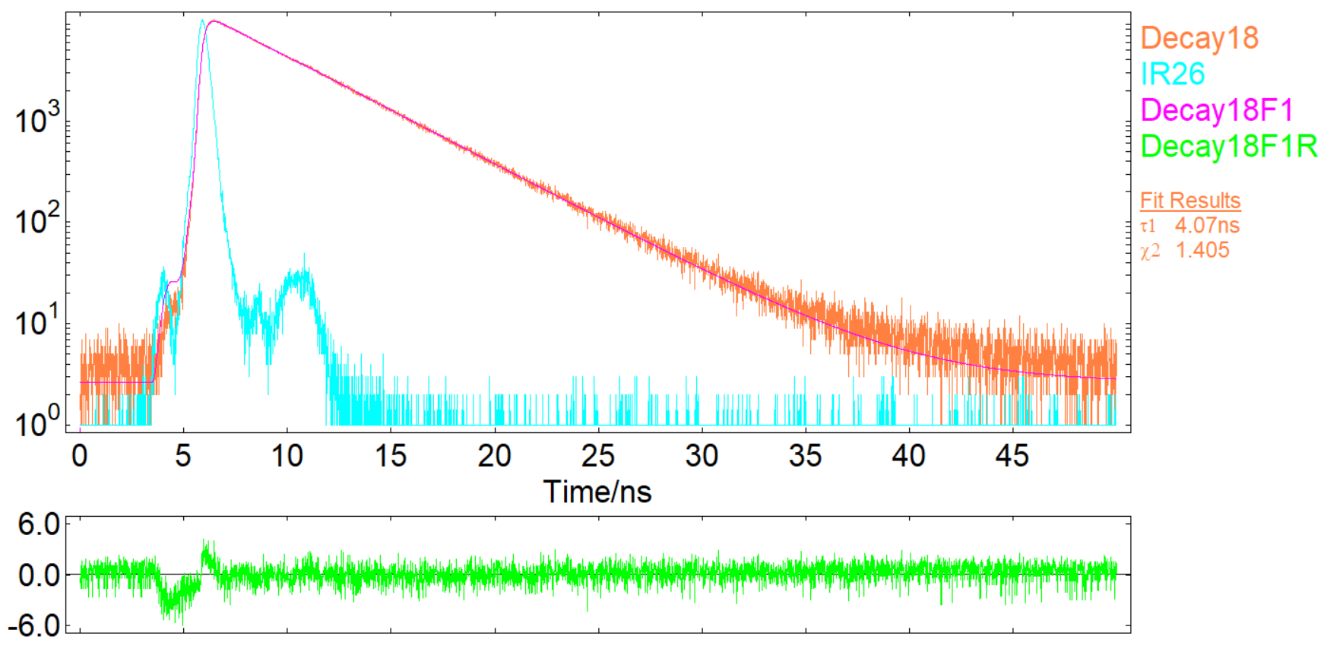

Multi-Channel Scaling (MCS)
Laser
Set the EPL or EPLED, switch it on then turn the dial to ‘Trigger input’.
Open ND filter completely.
Open : Setup → EPL(MCS) Laser set up and change the frequency to 100kHz and press “ok”
Put the Ludox sample in Set SR: Em λ = Laser λ_{L} nm, Em slits = 1-10 nm. (Depending on the laser)
Run a Lifetime scan (Ctrl + L); Time range: 40µs; 1000 channels; Stop condition: 10’000 peak counts.
You should see a pulse repeating every 10 µs. If it is then the MCS is working.
||Save as: “(laser name) MCS” e.g. “EPL365 MCS”
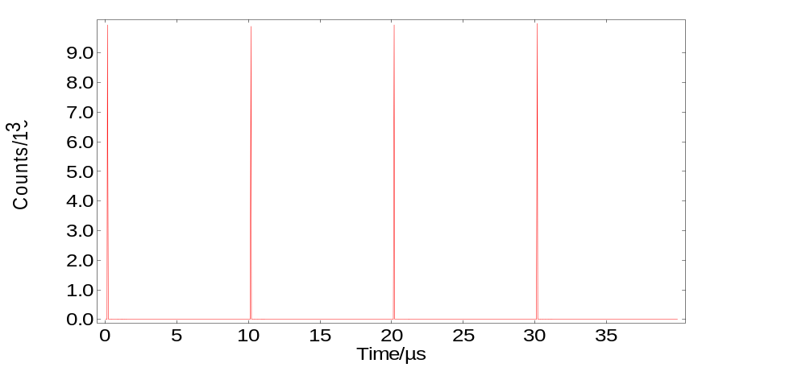
Figure 7: Laser pulses in MCS mode
Microsecond flashlamp
Choose microsecond flashlamp from light paths on signal rate
Put Europium sample in Set SR: Ex λ = 393.5 nm, Ex slits = ~1-3.5 nm; (<1’000cps to avoid saturation)
Em λ = 592.3 nm, Em slits = 1 nm.
Open the dialogue for Manual lifetime measurement (Ctrl + L) and select the following parameters:
Time range: 2ms, 1000 channels, Stop condition:10 000 peak counts → Press ‘►New’
Open: Analysis → Exp. Tail Fit (Ctrl + I), then put in a guess for the lifetime τ1 = 117µs.
Pass/Fail criteria: χ² must be lower than 1.3 if it is not increase the fitting range start point to only fit the decay tail to the function without the rising edge.
||Save as ‘eu mcs’
Note: The decay should have a straight slope in log scale as it begins to descend (i.e. no waves or second peaks should be present).

CNI - CW - External Laser
Connect the PM1 to the FS5 and the CNI PSU
Connect the CNI laser to the PSU. DO NOT REMOVE THE LASER LENS CAP.
Power the PSU on and then turn the key to power the laser on.
Switch to ‘Modulation’ at the back of the PSU and to ‘Pulse’ on the PM1
Open Fluoracle (Note: the laser will only work when Signal Rate is live)
Go to: setup → CNI Laser setup… (Ctrl + Alt + C) and change the frequency to 1kHz
To make sure the pulse width is changing turn the dial on the PM1 and look at the display on the PSU. If the display is changing as you turn the dial then the pulse width is changing.

Now change to ‘CW’ on the PM1 and turn the dial on the PSU. If the reading on the PSU display is changing then the laser output power is changing too.
Finally open the cassette lid to make sure the interlock is switching off the laser.

Polarisers

Set both polarisers in on Signal Rate. Excitation and Emission both at 0°.

Excitation polariser
Set both polarisers in
No sample Set SR: Ex λ = 500 nm, Ex slits = 5 nm;
Em λ = 200 nm, Em slits = 0 nm.
Open polariser calibration through engineering mode and align in / out position first. Change vertical position using arrows to maximise the signal on the reference detector. Press ‘apply’ then re-initialise the excitation polariser.
To align the angle place a polariser filter in the sample chamber on the excitation path at 90° then change the angle calibration value to minimise signal on the transmission detector. Apply and re-initialise.

Warning: Do not press several buttons at once. Wait for each operation to finish otherwise the software may not finish performing the previous operation and the polarisers will not initialise properly.

Remove the polariser filter before continuing.

Emission polariser

Ludox sample in Set SR: Ex λ = 500 nm, Ex slits = 5 nm;
Em λ = 500 nm, Em slits ≈ 1 nm. (Aim to get ~1’000’000.c.p.s.)

Warning: Be careful not to overexpose the PMT while opening polariser calibration window. Open the lid quickly if counts get over 1’500’000 cps

Set the Emission Polariser to 90° then open the polarisers calibration menu through engineering mode and align in / out position first. Change vertical position using arrows to maximise the signal on the PMT detector. Press ‘apply’ then re-initialise the excitation polariser..
Then align the angle motor by changing the angle calibration value of the emission polariser to minimise signal on the PMT detector. Apply and re-initialise.

Warning: Do not press several buttons at once. Wait for each operation to finish otherwise the software may not finish performing the previous operation and the polarisers will not initialise properly.

Excitation anisotropy scans of RhoB
Set both polarisers in.
Rhodamine B sample in Set SR: Ex λ = 560 nm, Ex slits = 3 nm;
Em λ = 620 nm, Em slits = 3 nm.
Open λ → anisotropy scan → Excitation: scan from 260 → 580nm, step = 1 nm, dwell = 0.5 s, repeats = 1
Tick: ‘Use G-factor correction’ and ‘measure to peak’

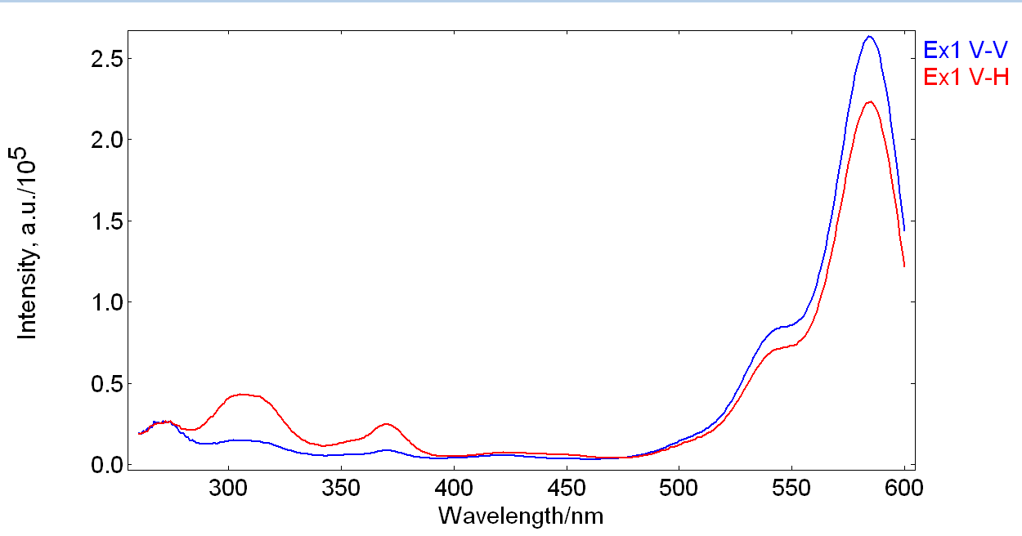
Figure 8: Excitation Anisotropy scan
(fig.8) ||Save as: ‘Rho Ani Raw’
Results:
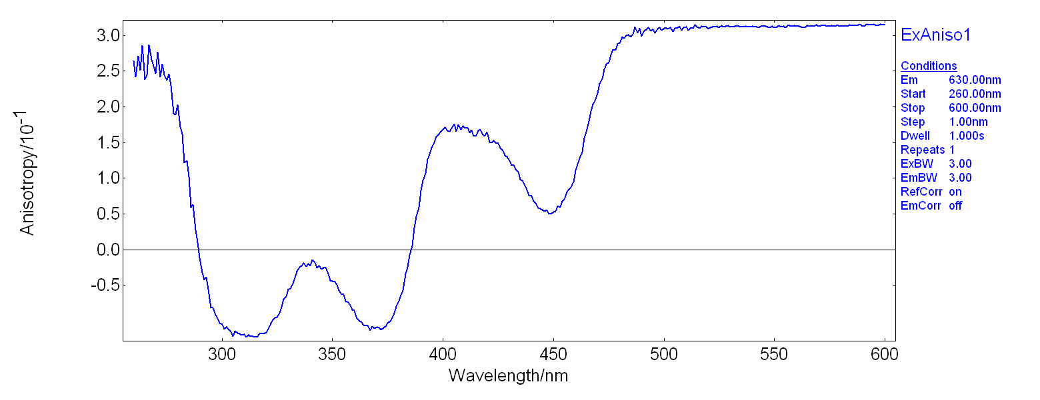
Figure 9: Excitation Anisotropy result
This scan to go in the test records ||Save as: ‘Rho Ani Result’

Pass/Fail Criteria:
The scan should look like the example given in figure 9 and should have the peaks at roughly the same wavelengths. Anisotropy should be more or less a flat line in the 500-600nm region. It should be ~0.3 or more but never higher than 0.4.

NIRA+ Detector (InGaAs)

Select ‘NIR InGaAs 1.65um’ from light paths Note: Save all scans inside the SC05 InGaAs folder

Grating Calibration
Sample: Nd:Yag (alignment sample) Set Signal Rate: Ex λ = 355 nm, Ex slits = 5 nm;
Em λ = 1064nm, Em slits = 2 nm.
The 1064nm peak signal at these parameters should be close to or over 100’000 c.p.s.

Run an emission scan (Ctrl + M) Ref correction: off Subtract background: off
Range: 900 – 1400nm, Step: 1nm, Dwell: 0.1s, Repeat: 1.
Theoretical Peaks: 946nm, 1064nm, 1319nm must match. || save as: ‘NIR cal’

SC05 Light Path Correction scans
Put the SC-60 Cassette in, disable sample module detection, select SC-60 and switch on the Tungsten lamp.
Tungsten Lamp Correction scan Set Signal Rate: Ex λ = 200 nm, Ex slits = 0 nm;
Em λ = 1200 nm (peak), Em slits = ~2-5 nm.
run a kinetic scan (τ) for 1800 seconds to ensure the lamp has warmed up and has stabilised.
Run an Emission Correction scan (CTRL + 5), subtract background: off
Em range: 500 – 1800nm Step: 2nm; Dwell time: 5 sec; repeats: 1.
Change lamp source name to ‘SC60-1(or 2) T’ || Save as ‘T Raw’ or ‘T Raw (detector)’
After you’ve finished enable sample module detection: Options → Sample modules → Ctrl + Alt + E
Reference Samples Scans Make sure the Xe lamp has been on for > 40 min
Put the SC05 Cassette in
Sample: DCM (EI-4) On Signal Rate: Ex λ = 450 nm, Ex slits ≤ 15 nm (aim to get at least 15’000 counts);
Em λ = 635 nm, Em slits = <7 nm.

Run an emission scan (Ctrl + M). Ref correction: off Subtract background: on
Range: 550 – 800nm, Step: 5nm, Dwell time: 10s, repeat 4.
|| save as: ‘EI-4 InGaAs’
Sample: LDS (EI-5) On Signal Rate: Ex λ = 520 nm, Ex slits ≤ 25 nm (aim to get a good signal);
Em λ = 730 nm, Em slits = 10+ nm. (at least 3000cps > dark counts).

Run an emission scan (Ctrl + M). Ref correction: off Subtract background: on
Range: 600 – 950nm, Step: 5nm, Dwell time: 10s, repeat 4.
|| save as: ‘EI-5 InGaAs’

For validation see section 4.1

SC30 Light Path Correction and Validation

Put the SC30 Cassette in. Create a sub folder in val and name it ‘SC30 InGaAs’ and save all the scans there.

Select ‘NIR InGaAs 1.65um’ from light paths. Make sure NIR grating has been calibrated (see 2.1.5).

Tungsten Lamp Correction Scan
Set up the small Tungsten (T) lamp by removing the left hand side baffle of the SC30 cassette and screwing the small lamp in its place and powering it on.
Set Signal Rate: Ex λ = 200 nm, Ex slits = 0 nm;
Em λ = 600 nm (peak), Em slits = ~2-5 nm.
Run a kinetic scan (τ) for 1800 seconds to ensure that the Tungsten lamp has warmed up and has stabilised.
Run an Emission Correction scan (CTRL + 5), subtract background: off
Range: 500 – 1800nm Step: 2nm; Dwell time: 5 sec; repeats: 1
Change lamp source name to ‘SC30 T’ || save as ‘T Raw Sphere InGaAs’
Note: The range starts at 500nm to allow the scan to cover the P2 powder peak range

Reference Samples Scans Make sure the Xe lamp has been on for > 40 min

Sample: P560 On Signal Rate: Ex λ = 440 nm, Ex slits ≤ 7 nm (or below ref detector saturation);
Em λ = 600 nm, Em slits = 10+ nm. (at least 1000cps > dark counts).

Run an emission scan (Ctrl + M). Ref correction: on Subtract background: on
Range: 470 – 750nm, Step: 5nm, Dwell time: 10s, repeat 4.
|| save as: ‘P560 Raw InGaAs’
Sample: Scattering Plate Keep all other settings as in the P560 scan

Run an emission scan (Ctrl + M). Ref correction: on Subtract background: on
Range: 470 – 750nm, Step: 5nm, Dwell time: 10s, repeat 4.
|| save as: ‘P560 ref InGaAs’
Now Open both scans in Fluoracle, place the ‘P560 InGaAs’ Scan in front of the ‘ P560 ref InGaAs’ scan and press: Data → Combine(+,-,*,/) → Subtract… Select the reference sample and press ‘Ok’
Use this scan as a correction factor for the SC30 InGaAs correction file || save as: ‘P560 InGaAs’

Sample: P2 On Signal Rate: Ex λ = 450 nm, Ex slits ≤ 7 nm (or below ref detector saturation);
Em λ = 650 nm, Em slits = 10+ nm. (+1000cps > dark counts).

Run an emission scan (Ctrl + M). Ref correction: on Subtract background: on
Range: 500 – 800nm, Step: 5nm, Dwell time: 10s, repeat 4.
|| save as: ‘P2 Raw InGaAs’
Sample: Scattering Plate Keep all other settings as in the P2 scan

Run an emission scan (Ctrl + M). Ref correction: on Subtract background: on
Range: 500 – 800nm, Step: 5nm, Dwell time: 10s, repeat 4.
|| save as: ‘P2 Ref InGaAs’
Now Open both scans in Fluoracle, place the ‘P2 InGaAs’ Scan in front of the ‘ P2 ref InGaAs’ scan and press: Data → Combine(+,-,*,/) → Subtract… Select the reference sample and press ‘Ok’
|| save as: ‘P2 InGaAs’

Select ‘Visible PMT-900 (980,1010)’ from light paths and use these settings:

Sample: P2 On Signal Rate: Ex λ = 450 nm, Ex slits ≈ 0.2 nm (or <1’000’000cps on EM);
Em λ = 650 nm, Em slits = keep as for InGaAs.
Run an emission scan (Ctrl + M). Ref correction: on Subtract background: on
Range: 500 – 800nm, Step: 2nm, Dwell time: 0.5s, repeat: 1
|| save as: ‘P2 Raw PMT900 (980, 1010)’
Sample: Scattering Plate Keep all other settings as in the P2 scan

Run an emission scan (Ctrl + M). Ref correction: on Subtract background: on
Range: 500 – 800nm, Step: 2nm, Dwell time: 0.5s, repeat: 1.
|| save as: ‘P2 ref PMT900 (980, 1010)’

Now Open both scans in Fluoracle, place the ‘P2 PMT900 (980,1010)’ Scan in front of the ‘ P2 ref PMT900 (980,1010)’ scan and press: Data → Combine(+,-,*,/) → Subtract… Select the ref. sample and press ‘Ok’
|| save as: ‘P2 PMT900 (980, 1010)’
Validation
After the correction files have been created for and assigned to the “SC30 – Integrating Sphere NIR” and the SC30 – Integrating Sphere VIS” light paths (see section 4.1), open the ‘P2 InGaAs’ and the ‘P2 PMT900 (980, 1010)’ scans and apply the correction to each P2 scan by pressing: Analysis → correction and choosing the corresponding light path correction file.
Then close the uncorrected scans and combine the two corrected scans in one window by pressing window → join visible (Ctrl + J). They should match. If not, the correction files are not working like they should.
Include this scan in the test records || save as: ‘P2 InGaAs vs PMT900 (980, 1010)’

NIR PMT-1400 Detector
SECTION UNDER DEVELOPMENT

NIR+ PMT-1700 Detector (TE Cooled - H10330C)

When setting up this detector consider three of the following factors:
- The highest negative bias Voltage (In the case of this detector -800V) will give the best lifetime response.
- The highest SNR will happen at the combination of highest possible PMT bias Voltage (-910V) and the lowest Threshold setting (-5mV) but there is a high risk of saturating the detector
- If the TCSPC option is requested with the detector then in order to have at least some reasonable range of usable EPL pulse frequencies the detector Dark counts need to be kept to a minimum (<50’000 for this detector)

Measure NdYag Em Cal
Measure Tungsten 900 – 1800
Microsecond flashlamp: measure NdYag lifetime at 1064nm (lifetime ~235us)

SECTION UNDER DEVELOPMENT

Cassettes
Cassettes should always be ejected when the Signal Rate window is live for automatic recognition.

SC-06 Dual Sample Holder for Absorption
SECTION UNDER DEVELOPMENT

SC-10 Solid Sample Holder (Upright/Tilted)
Check:
- The Cassette is recognised by the software
- Movement of sample holder.
- The interlock is working (shutter closes when lid is open)

SC-15 Solid Sample Holder (Horizontal)
- Create a folder inside val and name it “SC15 (detector)” save the scans there.
- Check:
- The Cassette is recognised by the software
- The interlock is working (shutter closes when lid is open)
- Unscrew the cassette baffles at the front and at the back.
- Put the sample plate in Set SR: Ex λ = 550 nm, Ex slits = 1 nm;
Em λ = 550 nm, Em slits = 0.1 nm.
- Align excitation and emission mirrors by turning the two screws at the back of each mirror. Align Excitation by aiming for the spot to hit the indent on the sample plate. Then align emission by looking at the signal rate on the emission detector (use interlock bypass to align).
If the signal gets too high while adjusting the emission side mirror decrease the Ex bandwidth and keep adjusting until you are sure you’ve reached the maximum.
- Secure the two mirrors by tightening two M2 hexs screws at the top of each mirror holder.
- Put the cassette baffles back in.
- Put P-560 (YAG:Ce) sample in Set SR: Ex λ = 440 nm, Ex slits = 0.5 nm;
Em λ = 550 nm, Em slits = 0.5 nm.
- Run an emission scan (Ctrl + M): Range = 460 – 800 nm, step = 1, dwell = 0.2sec
||Save as: ‘P560’
- If the emission peak has scattering peaks protruding from it put in a 455nm high pass filter to block the excitation peak from showing up on the scan. If that didn’t help speak to development.
||Save as: ‘P560 + 455nm high pass filter’

SC-20 cooled cuvette holder with magnetic stirrer
- Put the cassette in and Check that:
- The Cassette is recognised by the software
- The interlock is working (shutter closes when lid is open)
- No air leaks are present in the pipe system (blow at one end and make sure the air is coming out the other end and nowhere else around the cuvette holder)
- Put the magnetic stirrer sample in the sample chamber.
- Go to: Setup → Sample stirrer setup (Ctrl + S on empty Fluoracle screen).
- Increase the speed and make sure that the stirrer rotates well throughout the 10 speed settings. Make sure to put it back to 0 once finished to stop the current from driving through the board.
- If the stirrer isn’t working check the wires are connected well. If this didn’t help the cassette’s wiring needs to be checked.
- Take a temperature sensor and measure the temperature of the cuvette chamber, then go to SR → Engineering mode (Ctrl + Alt + E) → Temperature control and change the temperature setting to the reading you have acquired with the sensor.
- Once finished tie up the pipes in a little circle underneath the cassette.

SC-22 Temperature Controlled Solid Sample Stage
SECTION UNDER DEVELOPMENT

SC-25 TE-Cooled Sample Holder - Standard Range
- Switch Fluoracle off
- Get the TLC50 (TC-1) controller out, put the power cable on, connect it to the PC (Customer’s PC) and turn it on. (make sure the PC is connected to the internet before continuing)
- Put the cassette in the FS5 connect it to the TC-1 and press set to reset.
- Wait for the computer to install drivers automatically or Run the ‘Tapp’ from the usb stick provided with the controller. Instructions on how to use it will be in a text file with the app.
- Go to: Device manager → ports and write down the port number that is associated with the TLC50 (TC-1) controller.
- Open Configure940 → sample holders → TLC50 and set it to ‘Present’. Then open ‘serial’ and set it to ‘Present’ as well.
- Change the ComPort to the Port you have written down in step 4.
- Make sure the temperature range is -10 ̊C to 105 ̊C. Save and close Config940.
- Fill the plastic tub with clean cold water from the tap (approx. ½ full).
- Connect one of the black pipes from the cassette to the top of the water pump provided with the kit.
- Put the pump in the tub with water and connect it to TC-1 (It will only work when Signal Rate is on)
- Switch Fluoracle on. If the cassette is not recognised by the software connect the controller to a different usb port and repeat steps 4-7.
- Make sure that the water is running at a constant rate (if not help the pump by siphoning the air out) and then check inside the cassette to make sure there are no leaks anywhere.
- Go to: Set Up → Temp set up and change the temperature to make sure it is changing on the TLC50 (TC-1) as well.
- Check that the magnetic stirrer is working by going to: Set up → Temperature setup → Stirrer ‘on’. Put the magnetic stirrer sample in and make sure it is rotating and not jerking chaotically (remove the top lid of the cuvette to see inside it). When done switch the stirrer off and close.
- Put the DCM (EI-4) sample in Set SR: Ex λ = 450 nm, Ex slits = 1.5 nm;
Lamp Should Be on for >30min Em λ = 630 nm, Em slits = 1 nm.
Run a Temperature Map scan: λ → Temperature map → Emission scan setup Ref correction: on
Range: 460 – 850 nm, step: 2 nm, dwell: 0.5 sec Subtract background: on
Scan from: 10 – 60 °C, step: 10 K, accuracy band: ±0.5K, stabilisation time of 5 s || save as ‘DCM Temp’
- To switch off TC-1 first remove the cassette from the FS5 and then power off the controller.
- Copy “SC-25 TLC50 Instructions and Drivers” from: server1 → Manuals → FLS1000 Pen Root → Software onto the white usb key with the system settings.
- *(Skip this step if the Customer requested an installation) Create a text file named: ‘SC-25 CUSTOMER README’ on the usb key and put in the following text:
“ Please read the manual for FS5 installation instructions.
Note, please also run the 'tools' executable in the Fluoracle folder.
Please watch installation video tutorial and also the training video tutorials.
Please also read the SC25 installation instructions too (within folder) to assign driver and com port for this SC.
Note: The SC25 controller is configured to COM X. The USB port you plug the SC25 controller into on your own PC needs to be (or moved to) COM X. The communications are serial, not pure USB so the SC25 controller cannot be changed from this location.” Replace X with COM port number.
- Take a snip of the TLC50 calibration values inside Configure940 and add this snip to the test records after all the other calibration snips. Name the new box SC25.

SC-26 TE-Cooled Sample Holder - Extended Range
- Switch Fluoracle off
- Get the TLC50 (TC-1) controller out, put the power cable on, connect it to the PC (Customer’s PC) and turn it on. (make sure the PC is connected to the internet before continuing)
- Put the cassette in the FS5 connect it to the TC-1 and press set to reset.
- Wait for the computer to install drivers automatically or Run the ‘Tapp’ from the usb stick provided with the controller. Instructions on how to use it will be in a text file with the app.
- Go to: Device manager → ports and write down the port number that is associated with the TLC50 (TC-1) controller.
- Open Configure940 → sample holders → TLC50 and set it to ‘Present’. Then open ‘serial’ and set it to ‘Present’ as well.
- Change the ComPort to the Port you have written down in step 4.
- Make sure the temperature range is -50 ̊C to 150 ̊C. Save and close Config940.
- Fill the plastic tub with clean cold water from the tap (approx. ½ full).
- Connect one of the black pipes from the cassette to the top of the water pump provided with the kit.
- Put the pump in the tub with water and connect it to TC-1 (It will only work when Signal Rate is on)
- Switch Fluoracle on. If the cassette is not recognised by the software connect the controller to a different usb port and repeat steps 4-7.
- Make sure that the water is running at a constant rate (if not help the pump by siphoning the air out) and then check inside the cassette to make sure there are no leaks anywhere.
- Go to: Set Up → Temp set up and change the temperature to make sure it is changing on the TLC50 (TC-1) as well.
- Check that the magnetic stirrer is working by going to: Set up → Temperature setup → Stirrer ‘on’. Put the magnetic stirrer sample in and make sure it is rotating and not jerking chaotically (remove the top lid of the cuvette to see inside it). When done switch the stirrer off and close.
- Put the DCM (EI-4) sample in Set SR: Ex λ = 450 nm, Ex slits = 1.5 nm;
Lamp should be on for > 30min Em λ = 630 nm, Em slits = 1 nm.
Run a Temperature Map scan: λ → Temperature map → Emission scan setup Ref correction: on
Range: 460 – 850 nm, step: 2 nm, dwell: 0.5 sec Subtract background: on
Scan from: 10 – 60 °C, step: 10 K, accuracy band: ±0.5K, stabilisation time of 5 s || save as ‘DCM Temp’
- To switch off TC-1 first remove the cassette from the FS5 and then power off the controller.
- Copy “SC-26 TLC50 Instructions and Drivers” from: server1 → Manuals → FLS1000 Pen Root → Software onto the white usb key with the system settings.
- *(Skip this step if the Customer requested an installation) Create a text file named: ‘SC-26 CUSTOMER README’ on the usb key and put in the following text:
“ Please read the manual for FS5 installation instructions.
Note, please also run the 'tools' executable in the Fluoracle folder.
Please watch installation video tutorial and also the training video tutorials.
Please also read the SC26 installation instructions too (within folder) to assign driver and com port for this SC.
Note: The SC26 controller is configured to COM X. The USB port you plug the SC26 controller into on your own PC needs to be (or moved to) COM X. The communications are serial, not pure USB so the SC26 controller cannot be changed from this location.” Replace X with COM port number.
- Take a snip of the TLC50 calibration values inside Configure940 and add this snip to the test records after all the other calibration snips. Name the new box SC26.

SC-27 TE-Cooled Sample Holder - 4-Position
- Switch Fluoracle off
- Get the TLC50 (TC-1) controller out, put the power cable on, connect it to the PC (Customer’s PC) and turn it on. (make sure the PC is connected to the internet before continuing)
- Put the cassette in the FS5 and connect both the reference and the sample cables to the TC-1 controller and press ‘set’ to reset the controller.
- Wait for the computer to install drivers automatically or Run the ‘Tapp’ from the usb stick provided with the controller. Instructions on how to use it will be in a text file with the app.
- Go to: Device manager → ports and write down the port number that is associated with the TLC50 (TC-1) controller.
- Open Configure940 → sample holders → TLC50 and set it to ‘Present’. Then open ‘serial’ and set it to ‘Present’ and then under Serial → Heater module choose ‘Turret400’ as well.
- Change the ComPort to the Port you have written down in step 4.
- Make sure the temperature range is -25 ̊C to 105 ̊C. Save and close Config940.
- Fill the plastic tub with clean cold water from the tap (approx. ½ full).
- Connect one of the black pipes from the cassette to the top of the water pump provided with the kit.
- Put the pump in the tub with water and connect it to TC-1 (It will only work when Signal Rate is on)
- Switch Fluoracle on. If the cassette is not recognised by the software connect the controller to a different usb port and repeat steps 4-7.
- Make sure that the water is running at a constant rate (if not help the pump by siphoning the air out) and then check inside the cassette to make sure there are no leaks anywhere.
- Switch through the turret positions in Fluoracle and make sure that the position readings on the software and the TLC50 controller correspond with the position numbers in the cassette. If not, unscrew the numbered top lid of the turret and change accordingly.
- Go to: Set Up → Temp set up and change the temperature to make sure it is changing on the TLC50 (TC-1) as well.
- Check that the magnetic stirrer is working by going to: Set up → Temperature setup → Stirrer ‘on’. Put the magnetic stirrer sample in and make sure it is rotating and not jerking chaotically (remove the top lid of the cuvette to see inside it). When done switch the stirrer off and close.
- Put the DCM (EI-4) sample in sample 1 pos. Set SR: Ex λ = 450 nm, Ex slits = 1.5 nm;
Em λ = 630 nm, Em slits = 1 nm.
Put the QBS (EI-2) sample in sample 3 pos. Set SR: Ex λ = 350 nm, Ex slits = 1 nm;
Em λ = 435 nm, Em slits = 1 nm.
Click apply and close the Signal Rate window.
Make sure the lamp has been on for >30min and the emission filter wheel are on
Run a Temperature Map scan: λ → Temperature map → Emission scan setup
Set up Sample 1 (DCM EI-4): Tick Measure samples 1 and 3
Range: 460 – 850 nm, step: 2 nm, dwell: 0.5 sec Sub background: on Ref correction: on
Set up Sample 3 (QBS EI-2):
Range: 370 – 600 nm, step: 2 nm, dwell: 0.5 sec Sub background: on Ref correction: on
Temperature Scan Parameters
Scan from: 10 – 60 °C, step: 10 °C, accuracy band: ±0.5°C, stabilisation time of 5 s || save sample 1 as ‘DCM Temp’ and sample 2 as ‘QBS Temp’
- To switch off TC-1 first remove the cassette from the FS5 and then power off the controller.
- Copy “SC-26 TLC50 Instructions and Drivers” from: server1 → Manuals → FLS1000 Pen Root → Software onto the white usb key with the system settings.
- *(Skip this step if the Customer requested an installation) Create a text file named: ‘SC-26 CUSTOMER README’ on the usb key and put in the following text:
“ Please read the manual for FS5 installation instructions.
Note, please also run the 'tools' executable in the Fluoracle folder.
Please watch installation video tutorial and also the training video tutorials.
Please also read the SC26 installation instructions too (within folder) to assign driver and com port for this SC.
Note: The SC27 controller is configured to COM X. The USB port you plug the SC26 controller into on your own PC needs to be (or moved to) COM X. The communications are serial, not pure USB so the SC27 controller cannot be changed from this location.” Replace X with COM port number.
- Take a snip of the TLC50 calibration values inside Configure940 and save it as ‘SC27’ cal. Add this snip to the test records after all the other calibration snips. Name the new box SC27.

SC-28 Heated Sample Holder – Powders
SECTION UNDER DEVELOPMENT

SC-30 Integrating Sphere
For the InGaAs (NIRA+) SC30 Light Path see section 2.1.4
Make sure the emission filters are enabled. Set up the lamps by removing the left hand side sphere baffle and screwing the small lamp Deuterium (D) or Tungsten (T) in its place and powering it on.
Create a sub folder in val and name it ‘SC30 PMT900 (980,1010)’ and save the following scans there.
Deuterium (D) Set Signal Rate: Ex λ = 200 nm, Ex slits = 0 nm;
Em λ = 400 nm (peak), Em slits = 2 nm.
Wait for a minute for the lamp to come on, then increase Em bandwidth up to a maximum of 2 nm.
Run a kinetic scan (τ) for 1800 seconds to ensure the lamp has warmed up and has stabilised.
Run an Emission Correction scan (CTRL + 5): Range: 200 – 400nm, Step: 1nm Dwell: 2 sec; repeats: 1
subtract background: off
Change lamp source name to ‘SC30 D’ || Save as ‘D Raw Sphere’
Tungsten (T) Set Signal Rate: Ex λ = 200 nm, Ex slits = 0 nm;
Em λ = 600 nm (peak), Em slits = 0 nm.
Wait for a minute for the lamp to come on, then increase Em bandwidth slowly to get ~1’000’000cps.
Run a kinetic scan (τ) for 1800 seconds to ensure the lamp has warmed up and has stabilised.
Adjust emission bandwidth to get approximately 1,000,000cps. (Δλ_{em} ≈ 0.3nm)
Run an Emission Correction scan (CTRL + 5), Step: 1 nm Dwell time: 2 sec; repeats: 1
PMT900 range: 300 – 900nm, PMT980 range 300 – 1000nm, PMT-1010 range 300 – 1100nm; NIR detectors (see 2.1.4-6) subtract background: off
Change lamp source name to ‘SC30 T’ || save as ‘T Raw Sphere’ or ‘T Raw Sphere (detector)’
Reference samples
Check the Quantum Yield of the three highlighted EI samples (Table 2).
Sample: Ref 1 (for 2AMP, QBS, DCM) or Scattering Tray sample (for P-370, P-420, P-560).
Set Signal Rate: Ex λ = λ_{ex} nm, Ex slits (Δλ_{ex}) = 3 – 10 nm; (Aim to get ~900’000cps but below the ref. det. saturation),
Em λ = λ_{ex} nm, Em slits (Δλ_{em}) = 0.1+ nm.
If signal is too low, increase Δλ_{em}. If it’s too high at Δλ_{ex} = 3nm use a neutral density filter on the ex side.
Run an Em scan (Ctrl + M) using the settings of the sample you are going to measure then re-run for sample.
Step size should be <10% of Δλ_{ex} but never lower than 0.1nm. Ex correction: On; Subtract Background: On.
Visible Range 200 – 900nm
Once the two scans are done combine in one window and save according to the sample name (see table below)
Sample | λ_{ex} (nm) | λ_{em} (nm) | Step (nm) | t_{int} (s) | ~Δλ_{ex}/Δλ_{em}(nm) | QY (%) | || save as
EI-1 (2AMP) | 290 | 270 – 550 | 0.5 | 1 * 1 | 7/0.5 | 60 – 75 | 2AMP QY
P-370 (optional) | 280 | 260 – 450 | 0.5 | 0.2 * 1 |  | ~85 - 90 | P370 QY
P-420 (NaSal) | 320 | 300 – 650 | 0.5 | 0.2 * 1 | 7/0.4 | 40 – 50 | P420 QY
P-560 (Yag:Ce) | 440 | 420 – 850 | 0.25 | 0.2 * 1 | 4/0.1 | 88 – 98 | P560 QY
P2 | 450 | 500 – 800 | 2 | 10 * 4 | 7/10 |  | P2 QY
Table 3: Quantum Yield reference samples

SC-40 Plate Reader
Cassette has to be pushed very firmly in with screw tight. Needed for good electrical contact due to high current, without this the cassette won’t initialise properly.
Change cassette with sample holder options window open.
Alignment with camera.
Remove top cover from optics and then the mirrors and prism in their holder. If upgrade, remove the base part and replace with new part minus the aperture. Place the plastic cross-hair on the base mount using locating studs.
Mount webcam to silver camera mount. The clamp should be about half way on the camera shaft. Mount the camera plus mount onto the plate reader. Place a black well plate on the tray.
Using CNCcamera software (best to use computer different to that controlling FS5 so you see both at the same time) and fine tune the position of the camera so that it is looking straight down through the plastic cross-hair ( cross hair on camera lines up with upper of two lines – the one to the front of the PR) and is centrally over a well below it.
Open FSconfig and check the ‘length per step’ is 0.0140625 for both x and y motors and step to clear origin is x = 0 and y = 786.
Run Plate reader test software and open calibration window. Check cal point is x = 59.38 and y = 38.24. Initialise then initialise to cal point. Should be above D6 on well plate. Change cal (hitting apply each time and re-initialise to check)
Once calibrated to D6, check the alignment over the whole plate. If off, loosen and re-tighten four screws on base as evenly as possible.
Align Excitation mirror first (use clear well plate) so that none of the light hits the top of the well as this would cause scatter. The image of the aperture on the bottom of the well should be central on x and towards the emission side on y, this means it is in the middle of well half way down the well.
Align emission side using a sample and position for best peak signal.
Run scan, if there are many ‘ghost lines’ try to adjust ex mirror (then em again) so that the beam going into well is further away from the vertical axis. If not try a long pass filter in em arm.

OLD
Run SC40TestReader1 programme
Insert plate with calibration bolt.
Initialise, then move to calibration point.
Should be
X - distance at 51.4
Y - distance at 105.2
align to vertical post on right of prism block. Adjust offset so bolt and post are concentric, easily seen from above. Type in values and apply, do not scroll due to backlash.
X – in and out Y – left and right
Align excitation mirror first with small round extendable mirror so that brightest part of light is over small hole. 550nm ex wavelength, 5nm slit then 1nm slit to fine tune.
Align emission mirror with BaSO₄ in H12 and align for best signal. Near close alignment signal will go very high so be careful with slit size to avoid saturation on PMT.

For test records
Fluorescein scan, excitation and emission
peak at ex = 470nm, em = 510nm
Ex scan = 300 – 525 nm Em scan = 470 – 650 nm
Slits = 1nm 1 sec dwell time

SC-41 Microwell Plate Reader
Initial Calibration
Put the cassette in and Open: Configure 940 → Sample Holders → right click on SC40PlateReader and press ‘Restore subnodes to default’. Save and close Config.940.
Go to: C → Program Files (x86) → Edinburgh Instruments → Fluoracle and open ‘SC40TestReader’ then press ‘calibrate’ and ‘initialise’ in the next window.
Open the SC-41 cassette and look inside. The
Mirror Alignment
Test
Fluorescein repeatability scan
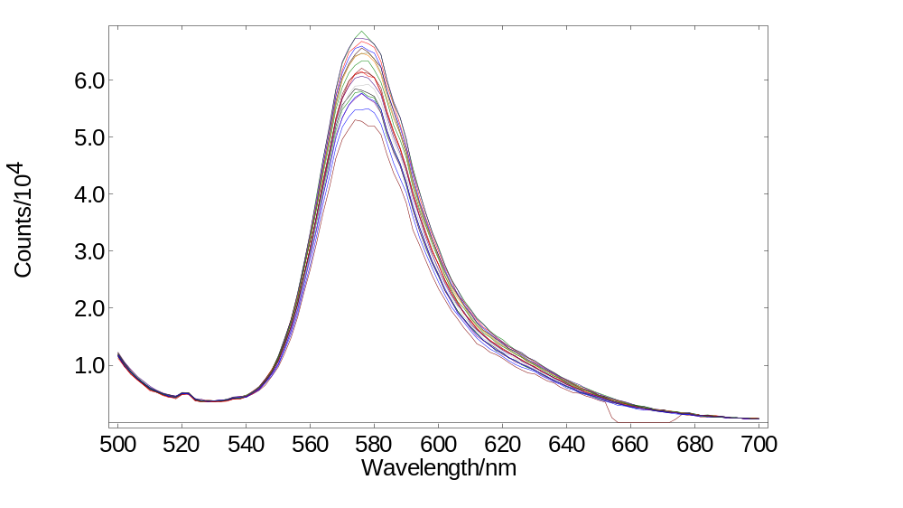

SC-50 Optical Fibre Launcher
SECTION UNDER DEVELOPMENT

SC-70 Liquid Nitrogen EPR Dewar
SECTION UNDER DEVELOPMENT

SC-80 Liquid Nitrogen Cryostat
Make sure the right Cryostat has been assigned to the job (T – Geometry for the FS5, L and X Geometry for FLS systems only) and check the temperature range against the customer order specifications
The standard Cryostat ranges from 77º - 300º Kelvin whereas the extended range cryostat goes up to 500º K.
Check that all the pipes are covered with plastic caps
Remove the sample holder to replace with another type is needed. Use gloves during the process. Be careful not to spill the sample inside the chamber if running a scan.
Make sure all the sample holders are present along with all the additional accessory.
Take the controller out, connect it to the computer and set it up in the software
Power it on and wait for it to load then press the right arrow → settings → remote access to USB and press ‘Apply’
Open device manager and check the USB port that it was assigned to
Go to: Config.940 → Sample Holders → Cryostat. Make it ‘Present’ then go to

Accessories

SCA-1 Solid Sample Holder
SECTION UNDER DEVELOPMENT

SCA-2 Solid Sample Holder with Rotation
SECTION UNDER DEVELOPMENT

SCA-3 Syringe Port
SECTION UNDER DEVELOPMENT

SCA-6 Stopped-Flow
SECTION UNDER DEVELOPMENT

SCA-7 Solid Sample Holder with Rotation
SECTION UNDER DEVELOPMENT

SCA-8 Electroluminescence Sample Holder
SECTION UNDER DEVELOPMENT

Light Path Naming
Excitation
Description | Light Path Name
Xenon 150W bulb | Xenon Lamp
Xenon 150W bulb + 250nm (or 750nm) blaze grating | Xenon Lamp + 250nm (or 750nm)
Ozone Generation 150W bulb | Xenon Lamp (Oz)
Ozone Generation 150W bulb + 250nm blaze grating | Xenon Lamp (Oz) + 250nm
5W Microsecond Flash lamp | Microsecond Flashlamp
EI EPL used in TCSPC mode. | TCSPC Diode
EI EPL used in MCS mode (present on every system with MCS) and also present with VPL | MCS Diode
CNI laser or external laser (without PM1) | External Laser
CNI laser systems with PM1 | External MCS Laser

Emission
Description | Correction File / Grating Range | Light Path Name
PMT-900 Detector (R928P) in Standard Housing | 200 - 900 | Visible PMT-900
PMT-900 Detector (R928P) in Cooled Housing | 200 - 900 | Visible PMT-900
PMT-1010 Detector (R2658P) in Cooled Housing | 200 - 1100 | Visible PMT-1010
High Speed PMT (H10720-01) in Standard Housing | 200 - 900 | High Speed PMT-850
High Speed PMT (H10720-01) in Cooled Housing | 200 - 900 | High Speed PMT-850
extended range High Speed PMT (H10720-20) in Cooled Housing, | 200 - 1000 | High Speed PMT-920
PMT-1400 in Liquid Nitrogen Cooled Housing(R5509-42), cut-off 1400 nm | 500 - 1500 | NIR PMT-1400
PMT-1400 in Peltier Cooled Housing (H10330B-45), cut-off 1400 nm | 900 - 1500 | NIR PMT-1400
PMT-1700 in Liquid Nitrogen Cooled Housing (R5509-72), cut-off 1700 nm | 500 - 1800 | NIR PMT-1700
PMT-1700 in Peltier Cooled Housing (H10330B-75), cut-off 1700 nm | 900 - 1800 | NIR PMT-1700
PMT-980 Detector in Cooled Housing (R13456P) | 200 - 1000 | Visible PMT-980
InGaAs detector with Integrated Lock-In - 1.65 µm cut-off - Steady state (G12180-230A) | 600 - 1800 | NIR InGaAs 1.65um
SC30 with whichever visible PMT is on the system (PMT-900, 980, 1010) |  | SC30 - Integrating Sphere (if NIR detector is present it would be called SC30 - Integrating Sphere Visible)
SC30 with whichever visible NIR detector is on the system (InGaAs, NIR PMT) |  | SC30 - Integrating Sphere NIR
SC50 with fibres, supplied by EI |  | SC-50 - Fibre Visible or NIR

Bandpass - Excitation/Emission | 0 to 30 nm, continuously adjustable
Wavelength Accuracy - Excitation/Emission | ± 0.5 nm
Water Raman Signal | >400,000 cps at 397 nm emission, excitation 350 nm, 5 nm bandpass, 1 s integration time
Signal-to-Noise Ratio of Water Raman Signal | SNR SQRT >6000:1
Dark Counts on the PMT | < 300 c.p.s.

Validation

Correction Files
You will need to generate a correction file for each emission light path (See Section 1.4 and 3 for light paths and ranges)

Correction File Generator

SC05 – Visible Range Detectors
- Create a sub folder inside each corresponding SC05 VIS detector folder and name it ‘ASCII files’
- Open the following scans in Fluoracle: D Raw, T Raw, 2AMP (EI-1) and QBS (EI-2), DCM (EI-4), LDS (EI-5).
- Export each scan as ASCII and save them inside the folder you have created keeping the same names.
- Go to: server1 → Shared → Applications Lab → Correction File Generator → Latest version and run the Correction File Generator.
- Choose ‘VIS’ under ‘Emission Light path’ and click ‘Apply’.
- Choose the Calibration lamp kit name (SC-60-1, SC-60-2 or N-2 for D2 and T2 lamps)
- Load the Tungsten and Deuterium ASCII lamp files you have created and then load all the relevant sample ASCII files.
- Under ‘Correction file generation’ select ‘Deuterium’ and ‘Tungsten’ and press ‘optimise curves’ then press ‘Generate Correction File’.
- Under ‘Correction file validation’ choose all the relevant samples and press ‘Validate’.
- If the validation curves are fitting well save graph as a .png file, if not apply the 2AMP correction factor and try again.
|| Save as ‘EI Samples Vs Ref’
- Under ‘Export’ tick ‘Correction file’ and Click Export.
||Save as ‘Em Cor (Detector) (job number)’ E.g. ‘Em Cor PMT-900 A1234-1’
- Open Fluoracle and import the generated correction file: File → Import ASCII file (Ctrl + A).
- Under ‘Type of container to create’ choose ‘Spectral emission scans’ and tick ‘Read X-values from column: 1’. Don’t change any other settings and press ‘Ok’. Same for the next window.
- Now open the unity scan: server1 → Analytical Software Records → Spectral correction files → unity_200-2100_as corr scan 0.05nm step
- Make sure the unity scan is in front of the correction scan in Fluoracle and open: Data → Combine → Multiply, Select the correction file and press ‘OK’
||Save the new scan keeping the same name as the ASCII file (see above).
- Copy the created file to: C: → ProgramData → Edinburgh Instruments → Fluoracle → Correction on the computer the system is connected to.
- Assign the newly created file to the right Detector light path in the software: Options → Correction Files → Visible PMT 900 (980, 1010) → modify and select the appropriate file.

SC05 – Near Infra-Red Range Detectors
- Create a sub folder inside each corresponding SC05 NIR detector folder and name it ‘ASCII files’
- Open the NIR detector scans in Fluoracle: T Raw, LDS (EI-5) and DCM (EI-4) for the InGaAs plus C153 (EI-3) for the NIR PMT-1700 and NIR PMT-1400
- Export both scans as ASCII and save them inside the folder you have created keeping the same names.
- Go to: server1 → Shared → Applications Lab → Correction File Generator → Latest version and run the Correction File Generator.
- Select ‘Auto subtract’ background and ‘Repair outliers’.
- Choose ‘NIR’ under ‘Emission Light path’ and click ‘Apply’.
- Choose the Calibration lamp kit name (SC-60-1, SC-60-2 or N-2 for the T2 lamp)
- Load the Tungsten ASCII lamp file you have created and then load the DCM (EI-4) and LDS (EI-5) ASCII files.
- Under ‘Correction file generation’ select ‘Tungsten’ and ‘EI-4 Corr. factor’ press ‘optimise curves’ then press ‘Generate Correction File’.
- Under ‘Correction file validation’ choose EI-5 and press ‘Validate’.
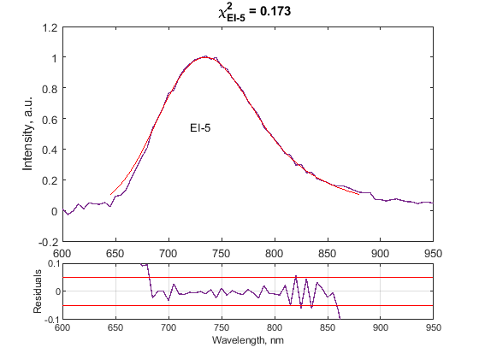
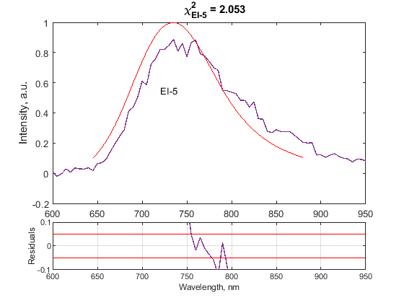
- If the validation curves are fitting well (see fig.7) save graph as a .png file, if not the correction file is not working like it should at the lower detector range.
Figure 7: EI-5 vs Reference without the correction factor (a) and with the Correction factor applied (b)
a)
b)

Include this scan in the test records || Save as ‘EI-5 Vs Ref’
- Under ‘Export’ tick ‘Correction file’ and Click Export.
||Save as ‘Em Cor (Detector) (job number)’ E.g. ‘Em Cor InGaAs A1234-1’
- Open Fluoracle and import the generated correction file: File → Import ASCII file (Ctrl + A).
- Under ‘Type of container to create’ choose ‘Spectral emission scans’ and tick ‘Read X-values from column: 1’. Don’t change any other settings and press ‘Ok’. Same for the next window.
- Now open the unity scan: server1 → Analytical Software Records → Spectral correction files → unity_200-2100_as corr scan 0.05nm step
- Make sure the unity scan is in front of the correction scan in Fluoracle and open: Data → Combine → Multiply, Select the correction file and press ‘OK’
||Save the new scan keeping the same name as the ASCII file (see above).
- Copy the created file to: C → ProgramData → Edinburgh Instruments → Fluoracle → Correction on the computer the system is connected to.
- Assign the newly created file to the right NIR detector light path in the software: Options → Correction Files → NIR InGaAs 1.65um (NIR PMT-1400, NIR PMT-1700) → modify and select the corresponding file.

SC30 VIS – Visible Range Detectors
- Create a sub folder inside each corresponding SC30 VIS detector folder and name it ‘ASCII files’
- Open the following scans in Fluoracle: D Raw Sphere, T Raw Sphere, 2AMP (EI-1) QY, P420 QY and P560 QY.
- Export each scan as ASCII and save them inside the folder you have created keeping the same names.
- Go to: server1 → Shared → Applications Lab → Correction File Generator → Latest version and run the Correction File Generator.
- Choose ‘Sphere VIS’ under ‘Emission Light path’ and click ‘Apply’.
- Choose the Calibration lamp kit (‘SC-61 in house’ for the small lamps)
- Load the Tungsten and Deuterium ASCII lamp files you have created and then load all the relevant sample ASCII files.
- Under ‘Correction file generation’ select ‘Deuterium’ and ‘Tungsten’ and press ‘optimise curves’ then press ‘Generate Correction File’.
- Under ‘Correction file validation’ choose all the relevant samples and press ‘Validate’.
Pass/Fail: Refer to Table 2 for the desired Quantum Yield for each sample.
|| Save as a .png file: ‘(sample name) QY’
- Under ‘Export’ tick ‘Correction file’ and Click Export.
||Save as ‘Em Cor (Detector) + Sphere (job number)’ E.g. ‘Em Cor PMT-900 + Sphere A1234-1.’
- Open Fluoracle and import the generated correction file: File → Import ASCII file (Ctrl + A).
- Under ‘Type of container to create’ choose ‘Spectral emission scans’ and tick ‘Read X-values from column: 1’. Don’t change any other settings and press ‘Ok’. Same for the next window.
- Now open the unity scan: server1 → Analytical Software Records → Spectral correction files → unity_200-2100_as corr scan 0.05nm step
- Make sure the unity scan is in front of the correction scan in Fluoracle and open: Data → Combine → Multiply, Select the correction file and press ‘OK’
||Save the new scan keeping the same name as the ASCII file (see above).
- Copy the created file to: C: → ProgramData → Edinburgh Instruments → Fluoracle → Correction on the computer the system is connected to.
- Assign the newly created file to the cassette’s light path in the software: Options → Correction Files → SC30 – Integrating sphere (Visible) → modify and select the file created for this light path.

SC30 NIR – Near Infra-Red Range Detectors
- Create a sub folder inside each corresponding SC30 NIR detector folder and name it ‘ASCII files’
- Open the NIR detector scans in Fluoracle: T Raw, P560 for the InGaAs plus the C153 (EI-3) QY and DCM (EI-4) QY and scans for the NIR PMT-1700 and NIR PMT-1400.
- Export both scans as ASCII and save them inside the folder you have created keeping the same names.
- Go to: server1 → Shared → Applications Lab → Correction File Generator → Latest version and run the Correction File Generator.
- Select ‘Auto subtract’ background and ‘Repair outliers’.
- Choose ‘NIR’ under ‘Emission Light path’ and click ‘Apply’.
- Choose the Calibration lamp kit name (‘SC-61 in house’ for the small lamps)
- Load the Tungsten ASCII lamp file you have created and then load the P560 ASCII file.
- Under ‘Correction file generation’ select ‘Tungsten’ and any correction factors (e.g. P560 for the InGaAs detector) made, press ‘optimise curves’ then press ‘Generate Correction File’.
- Under ‘Export’ tick ‘Correction file’ and Click Export.
||Save as ‘Em Cor (Detector) + sphere (job number)’ E.g. ‘Em Cor InGaAs + sphere A1234-1’
- Open Fluoracle and import the generated correction file: File → Import ASCII file (Ctrl + A).
- Under ‘Type of container to create’ choose ‘Spectral emission scans’ and tick ‘Read X-values from column: 1’. Don’t change any other settings and press ‘Ok’. Same for the next window.
- Now open the unity scan: server1 → Analytical Software Records → Spectral correction files → unity_200-2100_as corr scan 0.05nm step
- Make sure the unity scan is in front of the correction scan in Fluoracle and open: Data → Combine → Multiply, Select the correction file and press ‘OK’
||Save the new scan keeping the same name as the ASCII file (see above).
- Copy the created file to: C → ProgramData → Edinburgh Instruments → Fluoracle → Correction on the computer the system is connected to.
- Assign the newly created file to the right light path in the software: Options → Correction Files → SC30 – Integrating sphere NIR → modify and select the corresponding file.

Creating Correction Files Manually

Tungsten Correction File Generation in Fluoracle.
- Open raw tungsten file and change to log scale.
- Subtract baseline than count level at 300nm, this will put signal level at NIR end below 0.
- Right click on window and delete scan 3, range 680-900nm.
- Right click and insert the original scan 3 from the raw file, without the baseline subtraction.
- Click modify. Choose the T(x) lamp file: Server1 → analytical software records → Spectral correction files → Lamp folder (e.g. Cal module_SC-60-1) → most recent T(x) file created.
- Tick normalising, 3-way smoothing.
|| Save as ‘T(x) cor file’
Deuterium Correction File Generation in Fluoracle.
  - Open raw deuterium file.
  - Click analysis → generate correction file
  - Click modify, choose the appropriate D(x) file: Server1 → analytical software records → Spectral correction files → Lamp folder (e.g. Cal module_SC-60-1) → use most recent D(x) file.
  - Tick normalising, 3-way smoothing.
|| Save as ‘D(x) cor file’.
Joining Deuterium and Tungsten Files.
  - Put both corrected files in the same window.
  - Use cursor to find a wavelength around 360nm where the gradient is the same/similar and smooth for both scans.
  - Split each scan and place the deuterium scan in front of the tungsten file.
  - Click: Data → Combine → Append. The deuterium scan should be highlighted at the top. Choose the modified tungsten file and enter the wavelength value identified in set b).
  - Normalise to peak value of 1.
||Save as ‘Em. (job number) (Detector) Cor.’ E.g. ‘Em Cor PMT-900 A1234-1’
  - Copy the created file to: C: → ProgramData → Edinburgh Instruments → Fluoracle → Correction on the computer the system is connected to.

Checking Correction File.
  - Place newly made file in software: Options → Correction Files → Standard Light Path → modify and select the appropriate file.
  - Take the reference sample measurement and subtract solvent scan from sample scan, i.e 2AMP subtract ref.
  - Place the 3 new scans (QBS, DCM and 2AMP) in the same window and apply corrections: Analysis → Correction → Select all Scans.
  - Open EI reference measurement scans: Server 1 → Analytical Software Records → Spectral Correction Files → EI reference samples
  - Combine the corrected measured scans and EI reference ones and Normalise to 1. Check that measured and reference overlap well.
||Save as ‘EI Samples Vs Ref’

χ² Factor Validation
SECTION UNDER DEVELOPMENT

Test Records

Things to snip:
 | || Save as:
Ex mono calibration window from Test 940 | excal
Em mono calibration window from Test 940 | emcal
Cb/tcc threshold | card
Si detectors calibration window | sidet
water raman signal rate screen | wr
plate reader calibration | prcal
software version | sw
firmware version  Water Raman Signal Rate window | Firmware  Wr Sr

Copy the “Test records FS5 template.docm” into the validation folder with all the snips

SECTION UNDER DEVELOPMENT

